**React Using VITE**

**Open CMD/terminal**

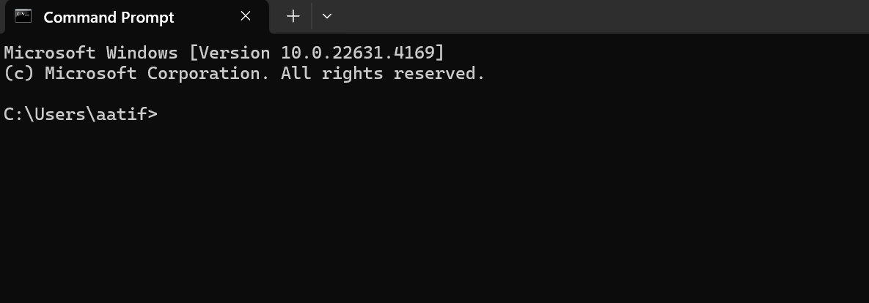

**npm create vite@latest**

**Project name: » new-app**

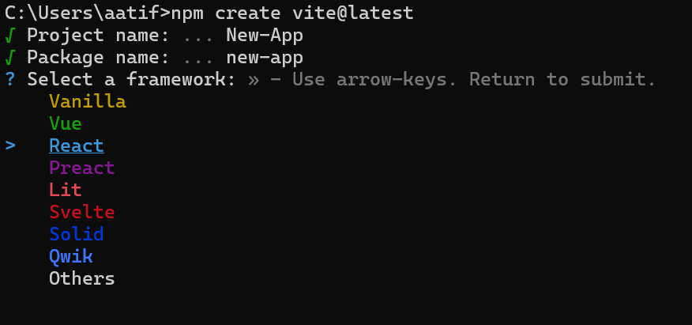

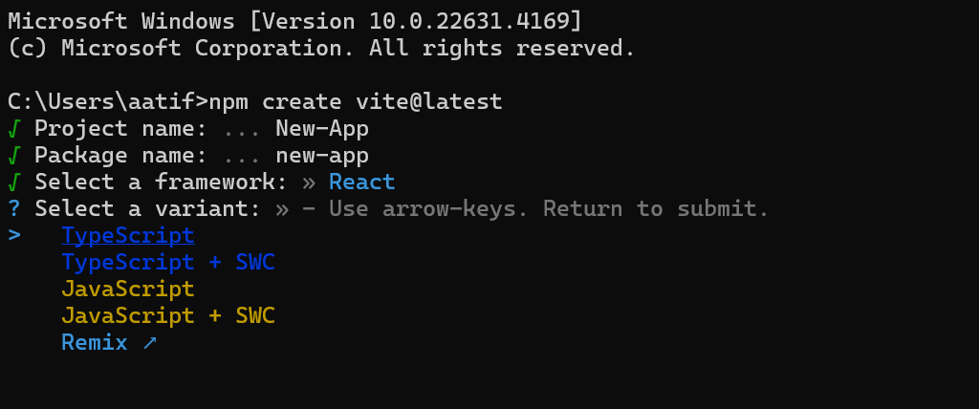

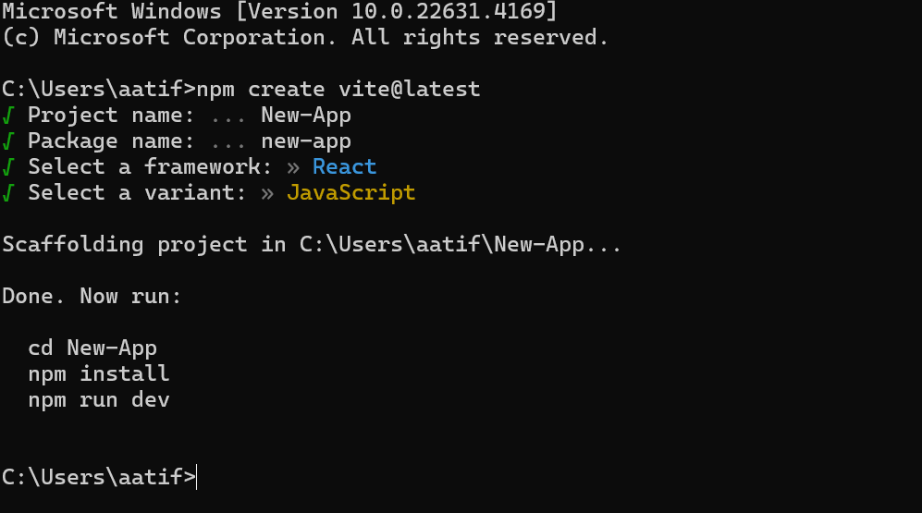

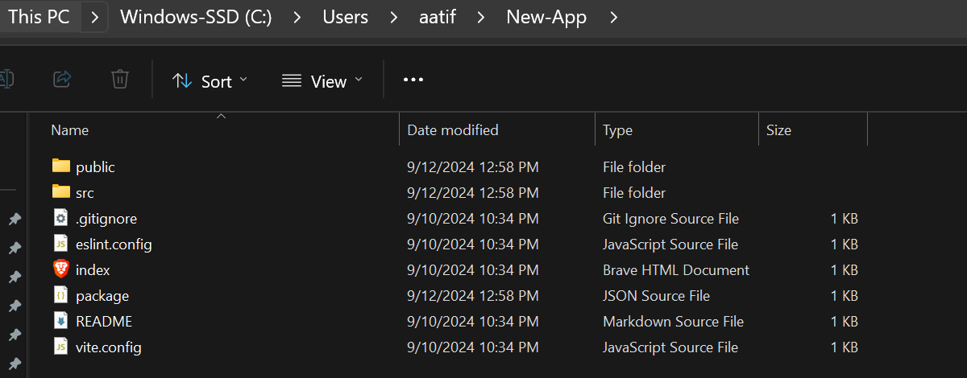

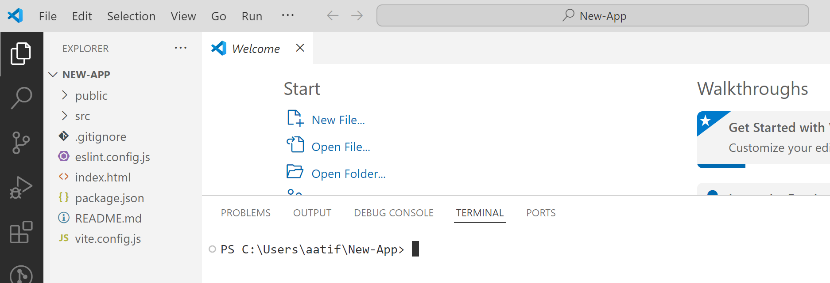

**npm install**

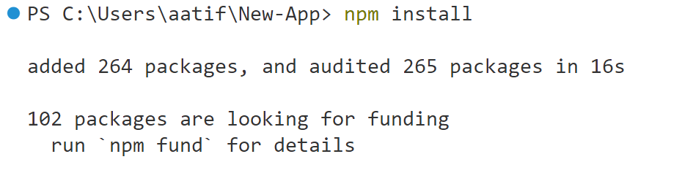

**npm run dev**

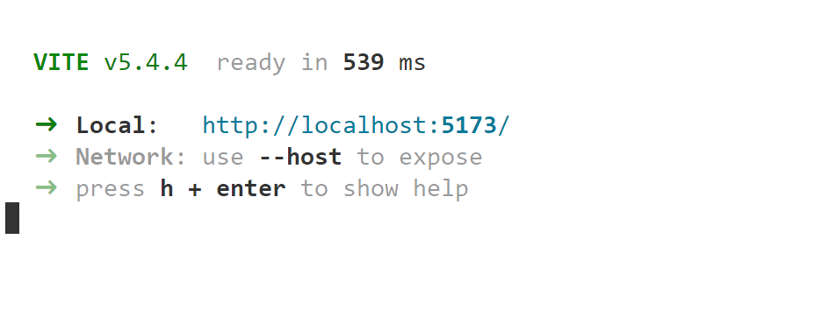

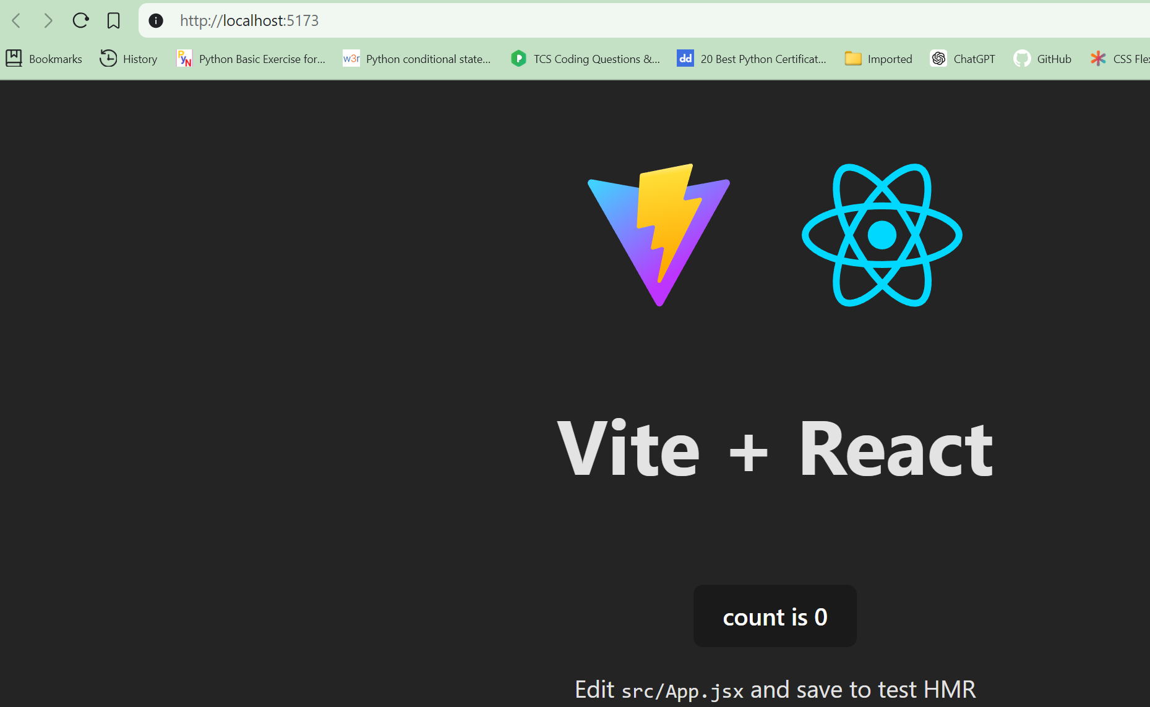

**// vite.config.js 🡺 to change the default port**

**export default {**

**server: {**

**port: 3000, // Change to your preferred port number**

**},**

**};**

